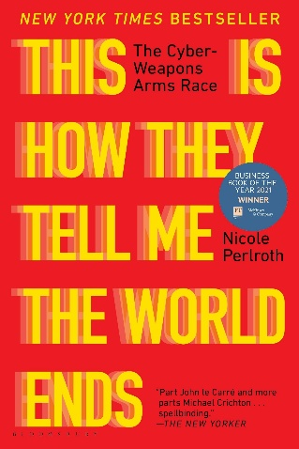
| This Is How They Tell Me The World Ends |
So This Is How They Tell Me the World Ends by Nicole Perlroth takes a deep dive into the world of zero-day exploits—hidden software vulnerabilities that hackers use to break into secure systems. The book explores how these exploits are sold and traded on the black market, and how governments and cybercriminals use them for everything from spying to launching cyberattacks. Perlroth explains how these vulnerabilities are like secret weapons in the digital world, with a price tag that can reach millions of dollars.
| My Impressions |
What really stood out to me is just how valuable these zero-day exploits can be. A single vulnerability can be worth millions, making it a high-stakes game for both hackers and governments. Some countries buy them to stay ahead in the cyber race, while others use them for intelligence or military purposes. This financial side of cyberattacks really shows how much is at stake in the world of cybersecurity.
Another important point in the book is how different political administrations understand and deal with cyber threats. Perlroth shows that sometimes, the heads of cybersecurity agencies aren’t taken seriously, or even worse, they’re fired for pushing back against political decisions. It’s shocking how often the people who warn about cyber threats aren’t listened to, which makes the world more vulnerable to attacks.
In all, So This Is How They Tell Me the World Ends was an eye-opening book that breaks down the complex world of cyberattacks and zero-day exploits in a way that’s easy to understand. It shows how these digital vulnerabilities are more than just technical issues—they’re a huge part of global security and politics.

